To reflect, means to think analytically about something or consider or think carefully about it. Reflection is a process that can help designers gain more insight into their creative processes, outcomes, and professional practice. The key to making reflection impactful and beneficial, is to reflect *critically*. This means questioning your assumptions, examining your own biases, as well as critically analysing your experiences and perspectives. Reflection encourages deep inquiry and challenges you to consider alternative viewpoints and the potential implications of your actions.

If you are not used to reflecting on your actions and experiences, it can be difficult to know where to start or how to conduct such an exercise. But, there is more than one approach to thinking more deeply about your work - a reflection can take various forms and modes.

### Written reflection

Written reflections involve the physical act of writing down your thoughts, experiences, interactions and insights. You can record your reflections as part of a blog or in a journal or even on a piece of paper. The act of writing down your reflections allows for deep introspection and can help clarify your thoughts and emotions. Writing also provides a tangible record that you can revisit and reflect on over time. [Studies](https://www.tandfonline.com/doi/citedby/10.1080/15401383.2017.1286277?scroll=top&needAccess=true) suggest that maintaining written reflections over time can contribute to improved self-awareness, emotional regulation, and psychological well-being.



Fig 1. Unsplash (n.d.) Reflective writing

### Verbal reflection

Talking (aloud) about your experiences and thoughts to yourself or with a trusted friend, mentor, or colleague can be a powerful mode of reflection. When you verbalise your thoughts, it can help you articulate ideas more clearly. In turn, these conversations or feedback can allow you to gain new perspectives on something, like your design approach or perhaps a solution to a design problem. You can capture your verbal reflections with a recording device, like a smartphone, and listen to it multiple times for deeper analysis and insight.



Fig 2. Pexels (n.d.) Reflecting verbally with others

### Artistic expression

If written or verbal reflection doesn’t provide the outcomes for you or you feel impeded by the format it takes, then perhaps you will find more value in expressing reflections through art, such as drawing, painting, or photography. This mode of reflection is especially popular among designers and other creative professionals, who prefer to express themselves artistically. Artistic mediums often allow for greater non-verbal expression of thoughts and emotions, enabling deeper exploration and understanding.



Fig 3. Pexels (n.d.) Creative reflection

### Mindfulness and meditation

Practising mindfulness and meditation techniques can also help you reflect on your actions and experiences. Mindfulness and meditation helps you to cultivate an awareness of the present moment and self-reflection. Taking the time to quiet the mind, noticing your body, feeling your breathing, and observing your thoughts without judgement can lead to profound insights and personal growth as a designer.

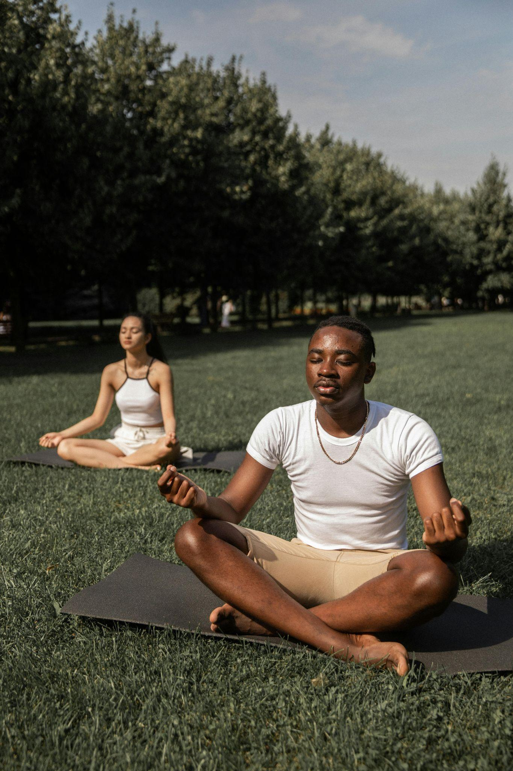

Fig 4. Pexels (n.d.) Practising mindfulness

### Group reflection

For some, reflecting with others might at first seem daunting. But participating in group discussions, workshops, or facilitated reflection sessions with peers or colleagues can offer diverse perspectives and collective insights which can lead to a richer learning experience. Group reflection fosters collaboration, shared learning, and mutual support in the reflection process which can also extend your own perspective to improve your creative practice. Group reflections can make use of written, verbal, or artistic forms of expression (or a combination) as part of the process.



Fig 5. Unsplash (n.d.) Group discussion

### Structured reflection models

Utilising structured reflection frameworks or models, such as Gibbs' Reflective Cycle or Kolb's Experiential Learning Cycle, can provide a systematic approach to your reflective activities. If you are new to reflective practices, it is worthwhile using one of these frameworks as a starting point. These models typically involve steps such as description, analysis, evaluation, and action planning, guiding you through a structured process of reflection.

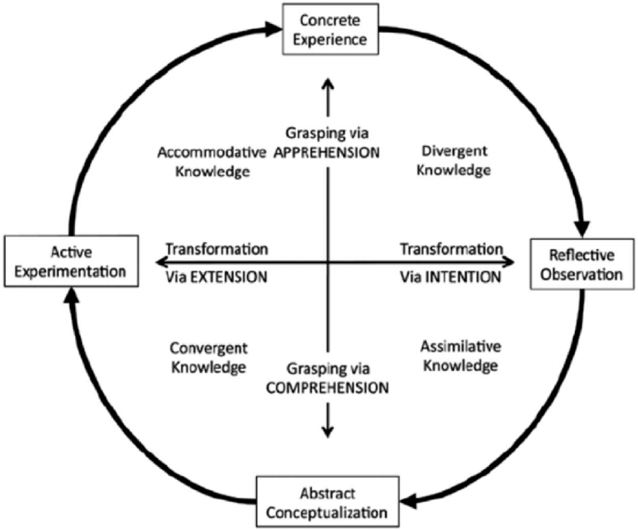

Fig 6. Kang & Martin (2018) Kolb’s 1984 Experiential learning cycle.

**Image (figure 6) reference:**

Kang, Da & Martin, Sonya. (2018). Improving learning opportunities for special education needs (SEN) students by engaging pre-service science teachers in an informal experiential learning course. *Asia Pacific Journal of Education.* 1-29. 10.1080/02188791.2018.1505599.